Indicator 4.3.4: Health Research Funding
Indicator Authors
Dr Will McDowall, Dr Hamid Nejadghorban, Dr Jake T.W. Williams
Methods
Our approach is based on a bottom-up aggregation of published grant-level data. Major funders of research publish information on funded projects, typically providing a project description or abstract. This data enables identification of health R&D on specific themes and issues, based on the text of the project description.
Dimensions Database
The Dimensions database has translated and aggregated information on project grants (1). Their database reports more than 8 million grants from just over 700 funders globally, from 44 countries. The database includes detailed project-level information, including the title, abstract, and information about the funded organisations and the funders.
Defining climate and health research
Our indicator aims to provide insight into the way in which health funders are responding to the way that climate change is reshaping the burden of disease. We are therefore interested in health outcomes associated with climate change, and hazard exposures created or exacerbated by climate change.
We exclude grants focused on action to reduce greenhouse gas emissions (GHG), since our focus is on the extent to which the health research system is addressing the ways in which climate change influences human health. This focus on the health consequences of a changing climate also means that we exclude health co-benefits of GHG reduction policies (such as the air pollution reductions associated with electrification of transport or other energy end-uses).

Identifying climate- and health-related research
The goal of the search strategy is to identify the share of global health research grants that is climate related, i.e. climate-related health research grants/all health research grants. This requires the development of search strategies that can identify all health research grants, and climate-related research grants.
We built strings of search terms to identify grants related to climate change and human health, following the approach used by Sovacool et al. 2024 (2) and Williams et al. 2026 (3)
To build the list of climate-related keywords, we first reviewed relevant previous studies that had sought to identify research related to climate change and health (2-5), or climate-related research more broadly (6). We extracted the search terms from these studies, focusing on those that were most common to create a shortlist of both climate- and health-related terms.
Climate-related search terms: The core search terms (“climate change”, “global warming” and “greenhouse effect”) are common to all four relevant previous studies, with some variations. Because we are not seeking to capture research on reduction of greenhouse gas emissions in healthcare contexts, we excluded grants using the phrase “global warming potential” (since this phrase largely appears in research on greenhouse gas reduction measures).
We also examined more specific climate-related terms that appear in two or more of the previous studies. For each of these, we conducted a search and then examined a sample of 20 resulting grants, in order to identify obviously problematic terms that yield too many false positives.
Our final search string for climate-related grants was: ((cyclon* AND (climate OR Tropical OR storm)) OR ("climate change" OR “climatic change” OR “changing climate” OR “climate crisis” OR “climate emergency” OR “climate extreme”~3 OR "global warming" OR "global heating" OR “warming world” OR "greenhouse effect" OR drought OR heatwave OR "heat wave" OR "extreme heat" OR "extreme weather"~3 OR “extreme precipitation”~3 OR "extreme rain"~3 OR “extreme rainfall”~3 OR wildfire OR "wild fire" OR "forest fire" OR "tropical storm" OR hurricane OR typhoon OR "sea level rise" OR "rising sea levels" OR “coastal flood” OR “river flood” OR “flash flood” OR “inland flood” OR “coastal flooding” OR “river flooding” OR “flash flooding” OR “inland flooding” OR “storm surge” OR “storm water”) AND NOT (“global warming potential”))
Health-related research
We also drew on previous relevant studies (2-5) to identify health-related keywords. Generic health-related terms (such as ‘disease’, ‘health’ and ‘mortality’) generate a high false positive rate if used alone, including false positives related to plant and animal health. Following Williams et al. (3), we combine generic health-related terms (illness, health, disease, death, infection/infectious, mortality, morbidity) with human-specific terms (human, children/child, maternal, men, women, etc.) in proximity searches. We also include terms that relate specifically to the context of health care and medicine, including medic*, hospital, public health and healthcare. Our list of broad health terms is as follows:
("public health"~5 OR healthcare OR "health care" OR “childrens health~5” OR “child health” OR “human health”~5 OR “infant health”~5 OR “maternal health”~5 OR “womens health”~5 OR “mens health”~5 OR medic* OR hospital OR “infant mortality” OR “maternal mortality” OR “child mortality” OR “human mortality”~5 OR “children mortality”~5 OR “mortality people”~5 OR “women mortality”~5 OR “human illness”~5 OR “illness women”~5 OR “illness men”~5 OR “illness children”~5 OR “human disease”~5 OR “infant disease”~5 OR “disease children”~5 OR “disease women”~5 OR “disease men”~5 OR medical OR “human death”~5 OR “child death”~5 OR “children death”~5 OR “infant death”~5 OR “human infection”~5 “children infection”~5 OR “child infection”~5 OR “women infection”~5 OR “men infection”~5 OR “human infectious”~5 OR “children infectious”~5 OR “child infectious”~5 OR “women infectious”~5 OR “men infectious”~5 OR “disability adjusted life year” OR “human morbidity”~5 OR “children morbidity”~5 OR “child morbidity”~5 OR “women morbidity”~5 OR “men morbidity”~5 OR “mental health” OR “mental illness” OR p?ediatric OR “health services” OR “global health”)
Using research classifications to identify health-related research
Search terms have weaknesses, and in order to provide an alternative way of identifying health-related research grants, we also use research classifications produced by Dimensions. Dimensions have used machine-learning to classify the grants in their database into broad fields (such as ‘biomedical research’) (1). Dimensions have done this for a variety of classifications systems of relevance to health research, using an initial training set to classify research from all funders. The relevant classification systems include i) ANZSRC: Australia and New Zealand Standard Research Classification, for which relevant tags are the groups 32 Biomedical and Clinical Research and 42 Health Sciences; ii) HRCS: Health Research Classification System, for which all categories are relevant; iii) UoA: Unit of Assessment (this classification system relates to the UK’s periodic research evaluation process, the ‘research excellence framework’, and relevant tags are categories A01-A04). We also examined a fourth classification (RCDC: the Research, Condition and Disease Categorization produced by the US National Institutes of Health), but initial testing revealed that RCDC tags had an unacceptably high false positive rate. We therefore used only ANZSRC, UoA and HRCS tags.
We also used Dimensions classifications to exclude a number of irrelevant codes, which either co-occurred with health codes, or which tended to occur with health keywords. These were identified by identifying codes that appeared unrelated to health research and that appeared in health keyword search results. For each of these codes, we tested 25 randomly selected grants to assess the false positive rate associated with them. As a result of this process, we excluded from further analysis any grants tagged with the following ANZSRC codes: 3001 agricultural biotechnology; 3003 animal production; 3004 crop and pasture production; 3005 fisheries sciences; 3008 horticultural production; 3009 Veterinary sciences; 3108 plant biology; 5002 History and Philosophy of Specific Fields; 43 History, heritage and archaeology; 36 Creative Arts and Writing; 4702 cultural studies; 4705 Literary Studies; 48 Law and legal studies.
Combining and testing search approaches
The health keywords and three relevant classification systems (ANZSRC, HRCS and UoA) were used as the building blocks for search strategies. Each search approach was used to retrieve grants, and two researchers (McDowall and Williams) then each manually and independently coded the same sample of 50 grants as either true positive or false positive for each search strategy. We then tested combinations of health search terms and classifications, which each generate a different balance between greater precision (requiring intersections between the search approaches through the use of AND) and recall (allowing unions of the search approaches through OR). In total we examined 11 combinations of keywords and classifications (health-related ANZSRC codes, all HRCS codes, and health-related UoA codes), based on four groups show in Table 1.
Table 1. Search approaches used to identify ‘health research’
Search approach group | Search approach
Baseline searches | Health keywords (HKW) only
 | ANZSRC health codes only
 | HRCS codes only
 | UoA health codes only
Intersections | HKW AND ANZSRC
 | HKW AND HRCS
 | HKW AND UoA
Unions | HKW OR ANZSRC
 | HKW OR HRCS
 | HKW OR UoA
Main search approach | Any three of HKW, ANZSRC, HRCS, UoA

Robustness check: funding patterns from health research funders
The majority of the false positives identified in our sample of retrieved grants were false because they were not health related, or were only indirectly health related. Given the challenges of using keywords and Dimensions classifications to identify health-related research grants, we have explored an alternative approach to identifying health-related research funding: grants made by health-specific funding bodies. This approach uses the same method of identifying climate-related grants (based on the climate keywords), but a completely independent way of identifying health-related research grants.
Focusing on research funded by health-specific funders is only possible for a subset of countries, since many countries fund health research via generic science or research funding agencies (e.g. China funds biomedical research through its National Natural Sciences Funding Council). Even within countries with dedicated health research agencies, there is likely to be health-related research taking place in other funders (such as environmental health research funded by environment-related research funders). Nevertheless, looking at climate-related grant funding as a share of grants funded by health-specific funders provides an alternative way of identifying climate and health research, and thus enables a robustness check on the trends observed using our main search approach.
We looked at 169 health-specific funders from 19 countries, accounting for 1,039,257 grants (roughly 1/8th of all grants tracked by Dimensions across all fields of research). The resulting pattern—from 2015 onwards—is shown in Figure 1, compared to our main search approach which combines health keywords and research classifications for the world as a whole.

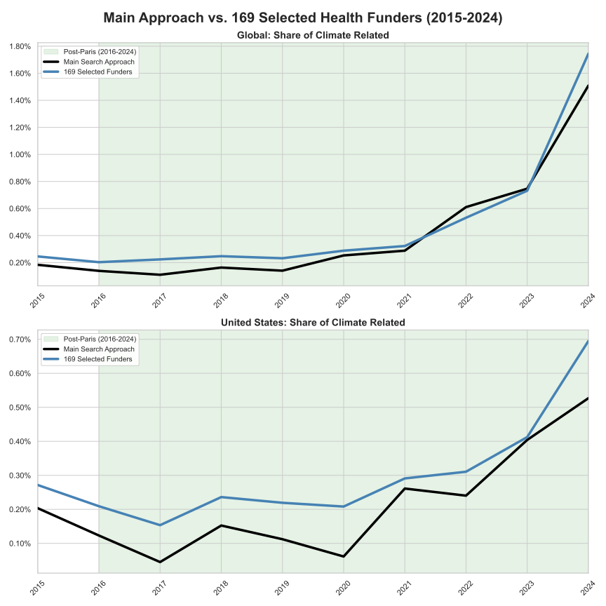
Figure 1. Share of funding that uses climate keywords based on different approaches to identifying health research: our main search approach, and funding from health-specific funders
The pattern is very similar, both globally and for the US. The similarity across the two approaches provides greater confidence in the robustness of the trend observed. While both rely on climate keywords, they use different ways of defining and measuring ‘health research’.

Caveats and Limitations

Data limitations
There are clear weaknesses to the underlying grant-level data. First, not all research funders provide transparent information about funded projects—particularly funders in low-income countries. The data is dominated by countries that have greater transparency in their research funding systems. These countries tend both to be richer countries, and those that fund the great majority of health research (on a per GDP basis and in absolute terms).
For regional/country analysis, this means that there are substantial gaps. Only two African countries are found in the data, and even for these countries the data on funding amounts (rather than grant numbers) is extremely limited. Data is also weak for South America (with data only available for Brazil, Chile, and Uruguay, and only for grant numbers rather than values). Data for Asia is dominated by East Asia (Japan, South Korea, China and Taiwan), with weak or absent data for many other Asian countries, particularly those with low incomes. A notable weakness in the data is limited coverage of research funding in China: grants from China’s National Natural Science Foundation are included in the data, but only up to 2020.
The data reflect the choices made by the largest funders of health research globally, and thus despite coverage weaknesses, the data can be considered broadly representative of global health research trends. WHO data on total health funding in 74 countries suggests that high income countries spend vastly more on health research than middle and low-income countries. High income countries spend around 0.27% of GDP on health research, much higher than upper-middle-income (0.03%) or lower-middle-income or low income countries (less than 0.02%) (7). Combined with the effects of higher GDP in high income countries, these figures demonstrate the extent to which the research trends among funders in higher income countries are a good description for global trends in health research. However, regional detail—and thus differences in regional patterns of research funding allocation—is only available for North America, East Asia, Europe and Oceania, and a few countries elsewhere (e.g. Brazil, Chile, Russia until 2022, South Africa and Israel). An important limitation of the data is that it is not possible to identify the research priorities of low-income countries, as expressed in their allocation of research grants.
A further weakness is that the data only represents project grants. In most countries, research funding is distributed both through project grants, and through core funding to research institutions such as universities or national laboratories (8). The allocation of such ‘core’ or ‘block’ funding to specific research themes is not visible from grant-level data. We can provide an approximate estimate of the coverage of health-related R&D in the Dimensions database by comparing it to other estimates of total global health research. The only figure we can identify that enables a direct comparison, i.e. focused on global publicly-funded (governments and foundations) health-related R&D spending is from Chakma et al. (2014) (9), from which the most recent year given is 2012. Dimensions data reports global health R&D from funders (governments and foundations) at around USD$56bn in 2012. Chakma et al. (9) estimated around $102bn. This suggests that Dimensions data covers a large share of global health-related R&D, but it also highlights the limitations of the data. In particular, the omission of core (not grant-specific) funding to research institutions means that the total volumes of funding are underestimated by Dimensions – and it is not known whether core funding might differ from grant funding in terms of the focus of research priorities.
It is important to note that the relative share of research funding that is delivered through project-specific grants rather than core institutional funds differs by country (10). This means that care should be taken in comparing absolute amounts of climate-related health research between countries, since differences in absolute amounts may reflect research funding models as much as real differences in the scale of research funding. The ratio of climate-related health to total health research is more straightforward, enabling a comparison of the relative focus of grant funding in health research on climate change. Data on grants in China substantially understates total levels of public research expenditure, both because a large portion of funding is delivered institutionally (rather than by projects), and also because of limited coverage in Dimensions of the full range of grant funding organizations in China. Comparing figures for 2019, China’s National Bureau of Statistics reports total government R&D investments in that year of around US$78.8bn, while the value of all grants starting in that year in Dimensions accounts for only US$3.9bn.
Our approach aims to track public spending on health-related R&D by governments and charitable foundations. This includes funders associated with national governments, international organisations (such as the WHO and the European Commission), and national and international charitable foundations (such as the Bill & Melinda Gates Foundation and the Wellcome Trust). It is important to note that we omit private sector spending, despite this playing a critical role in global health systems: Røttingen et al. 2013 (11) estimate that private businesses account for around 60% of health-related R&D spending globally. However, data on private spending on health R&D by topic is extremely limited, as such data is often commercially sensitive. We instead focus on public spending—which is also more directly policy relevant, since it directly relates to public policy choices.
Limitations to the search strategy
There are also limitations to the search strategy, based on keywords and the machine-learning-derived research classifications produced by Dimensions. These result in both false positives and false negatives.
It is important to be aware of the limitations of a keyword-based classification in drawing conclusions from comparisons across countries, since cultural differences in the style of project descriptions may have an influence on the apparent climate-relatedness of research. For example, some countries may expect grant descriptions to provide more discussion of the wider context for the research (including climate change), whereas others may be more narrowly focused on describing the details of the proposed research.

Future form of the indicator
In future years, we plan to use machine learning and supervised AI to support the classification approach. This will enable a more accurate assessment of false positives and false negatives, such that the robustness of the findings can be better assessed. We also plan to include estimates of the share of research funding that relates to the most widely discussed climate-sensitive diseases.

Additional analysis
Regional variation in climate-intensity of health research
The data suggests that countries differ in the extent to which their health research funding is focused on climate change. Here, we compare the global trend with the trends for three WHO regions: the Americas, Europe and Western Pacific (Figure 2, Figure 3). Note that coverage of the Dimensions database differs across these regions (see Table 2).
Table 2. Country-level coverage of Dimensions data on funders of climate-related health research funding
WHO Region | Data available on grant funding by value | Data available on number of grants
Americas | US, Canada, Bahamas | US, Canada, Bahamas, Chile, Brazil, Uruguay
Europe | Austria, Belgium, Croatia, Czechia, Denmark, Estonia, Finland, France, Germany, Hungary, Ireland, Italy, Latvia, Netherlands, Norway, Poland, Portugal, Russia, Slovakia, Spain, Sweden, Switzerland, United Kingdom | As for value, but also Luxembourg, Slovenia and Turkey.
Western Pacific | Australia, China, Japan, NZ, and limited data for India | As for value, but also Malaysia, South Korea
Other | Israel | Qatar, South Africa, United Arab Emirates

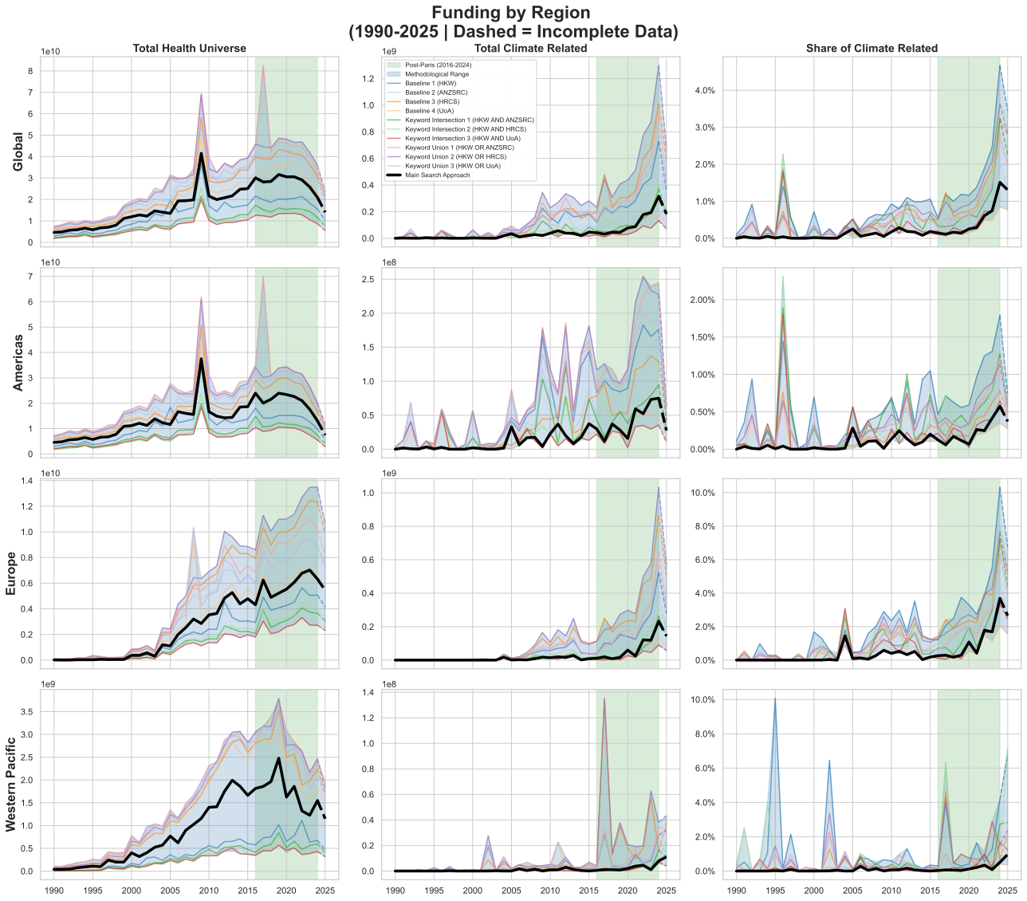
Figure 2. Total health funding (left panels) in USD, climate and health spending (central panels) in USD, and the share of health spending that is climate related (right panels).

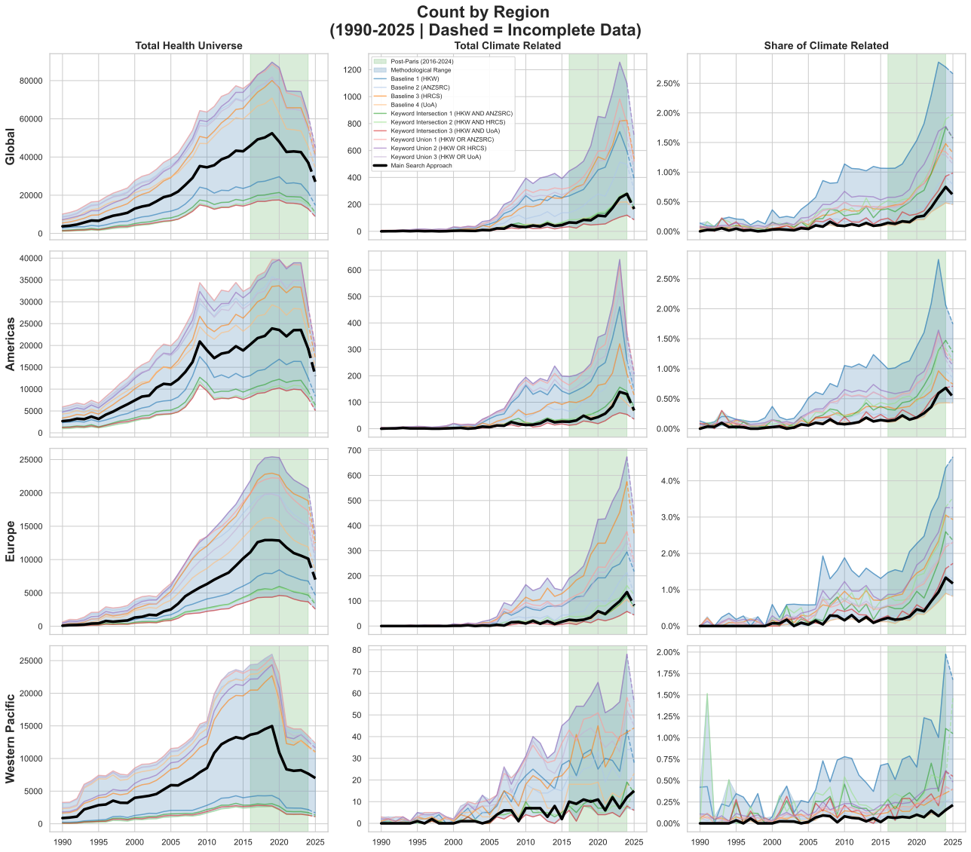
Figure 3. Total number of health related grants (left panels), climate-and-health grants (central panels), and the share of health grants that are climate-related (right panels).
We do not provide a breakdown by HDI region because of data limitations. Countries with lower HDI (i.e. not “very high”) in our dataset have weaker data, with several reporting only project counts rather than funded values (Nigeria, Brazil, South Africa) and others having patchy data coverage (China, for which the single biggest funder drops out of the data after 2020). The overwhelming majority (>95%) of health-related research tracked in Dimensions is from countries with very high Human Development Index (HDI) scores.

Checking robustness: changes in funder portfolio over time
Not all funders provide data for the full period under analysis, and there is a decline in the number of funders for which data is available in the most recent years (2020-2024). A particularly notable omission from the data post-2020 is the National Natural Science Foundation of China. Many of these funders can be assumed to still be funding health-related research, but their data is not available. It is likely that this shift in the population of reporting funders drives some of the apparent increase in the share of health research that is related to climate change. We looked at the share of climate-related health research in funders that continued to report data up to 2024 (Figure 4). Within these funders, we see a consistent growth in the share of climate-related health over time. This shows that the observed growth in the share of climate-related research is not simply an artefact created by a shifting portfolio of funders.

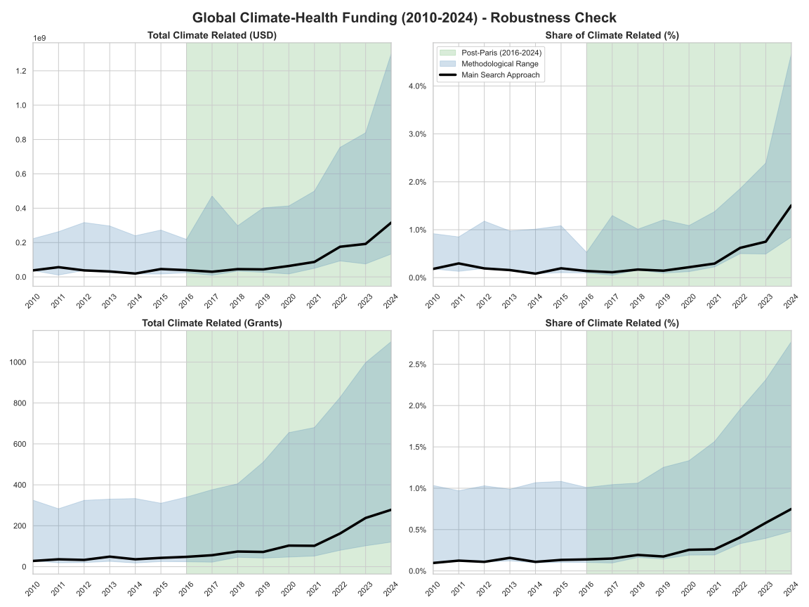
Figure 4. Climate-related health research spending (upper panel) and grant numbers (lower panels) from funders that report funding in 2024

References
1. Bode C, Herzog C, Hook D, McGrath R. A guide to the Dimensions data approach. Dimensions Report Cambridge, MA: Digital Science. 2018.
2. Sovacool BK, Clifford H, Pearl-Martinez R, Gause E, Braun D, Kamareddine L, et al. Critically examining research funding patterns for climate change and human health. npj Climate Action. 2024;3(1):64.
3. Williams JTW, Colagiuri P, Beggs PJ, Zhang Y. Disparities in health and climate change research funding: The funders and the funded. The Journal of Climate Change and Health. 2026;27:100633.
4. Berrang-Ford L, Sietsma AJ, Callaghan M, Minx JC, Scheelbeek PF, Haddaway NR, et al. Systematic mapping of global research on climate and health: a machine learning review. The Lancet Planetary Health. 2021;5(8):e514-e25.
5. Anon. Resourcing climate and health priorities: mapping of international finance flows 2018-2022. Methodology Note. Report funded by Foundation S, Reaching the Last Mile, The Rockefeller Foundation and RF Catalytic Capital. https://www.rockefellerfoundation.org/reports/resourcing-climate-and-health-priorities-a-mapping-of-international-finance-flows-from-2018-2022/. 2025.
6. Overland I, Sovacool BK. The misallocation of climate research funding. Energy Research & Social Science. 2020;62:101349.
7. WHO. Gross domestic R&D expenditure on health (health GERD) as a % of gross domestic product (GDP). Global Observatory on Health Research and Development. https://www.who.int/observatories/global-observatory-on-health-research-and-development/indicators/gross-domestic-r-d-expenditure-on-health-as-a-percent-of-gross-domestic-product. 2025.
8. OECD. Effective operation of competitive research funding systems. OECD Science, Technology and Industry Policy Papers No. 57: Paris: OECD Publishing; 2018.
9. Chakma J, Sun GH, Steinberg JD, Sammut SM, Jagsi R. Asia's ascent—global trends in biomedical R&D expenditures. New England Journal of Medicine. 2014;370(1):3-6.
10. Reale E. Analysis of national public research funding-pref. JRC-European Commission. 2017.
11. Røttingen J-A, Regmi S, Eide M, Young AJ, Viergever RF, Årdal C, et al. Mapping of available health research and development data: what's there, what's missing, and what role is there for a global observatory? The Lancet. 2013;382(9900):1286-307.

